TIME SERIES MODELLING OF COVID-19 UPTAKE IN KENYA
CHAPTER ONE
INTRODUCTION
The COVID-19 pandemic has presented extraordinary challenges to global public health systems, economies and societies requiring swift and effective responses to control the spread of the virus and moderate its impact. Vaccination campaigns have emerged as a critical tool in this effort, offering a pathway toward achieving mass immunity and reducing the burden of COVID-19 on societies worldwide. In Kenya, as in many other countries, the rollout of COVID-19 vaccines represents a main stage in the fight against the pandemic.
The success of vaccination campaigns hinges in the availability of vaccines and their uptake within the population. Understanding the factors influencing vaccine uptake and accurately predicting future uptake patterns for guiding policy decisions, resource allocation, and public health interventions. Vaccine uptake patterns are influenced by multiple factors such as vaccine hesitancy, access barriers and social-culture determinants. Previous research by Larson et al. (2021) has highlighted the importance of understanding these factors and their impacts on vaccine acceptance rates across diverse population.
Additionally, MacDonald (2015) emphasized the role of social networks and community influences in shaping vaccination behavior. By identifying patterns in COVID-19 vaccine uptake, there is insight into the divers of vaccine behavior and tailor intervention strategies.
Time series analysis, particularly the Autoregressive Integrated Moving Average (ARIMA) model, has proven to be a valuable tool in forecasting disease trends and health care outcomes. Studies by Correa et al. (2020) and Li et al. (2021) demonstrated the effectiveness of ARIMA modeling in predicting influenza vaccination rates and COVID-19 demand. By applying ARIMA model to COVID-19 vaccine uptake data in Kenya an accurate forecasting models that can inform decision making and optimize vaccination strategies was developed.
The main goal of this project is to analyze historical data on COVID-19 vaccine uptake in Kenya, identify underlying patterns and trends, and develop a predictive model capable of forecasting future vaccine uptake. It also lies in its potential to contribute to the understanding of COVID-19 vaccine uptake dynamics in Kenya and guide evidence based public health interventions. This project provides actionable insights that can inform decision-making and support the optimization of vaccination campaigns in Kenya.
A comprehensive analysis of historical data on COVID-19 vaccine uptake in Kenya was used to examine trends over time, seasonal variation and other patterns to help uncover into the dynamics of vaccine uptake and the factors driving its variability.

BACKGROUND OF THE STUDY
The emergence of the novel coronavirus, SARS-CoV-2, and the subsequent global spread of COVID-19 have triggered an extraordinary public health crisis, challenging healthcare systems, economies, and societies worldwide. Since its first reported case, the COVID-19 pandemic has profoundly impacted nearly every aspect of human life, leading to widespread illness, mortality, and socioeconomic disruption. In response to this crisis, efforts to develop and distribute safe and effective vaccines have been accelerated, offering a promising avenue for controlling the spread of the virus and justifying its impact.
In Kenya, like many other countries has been significantly been impacted by the COVID-19 pandemic facing challenges in straining healthcare resources, disrupting livelihoods, and worsening existing vulnerabilities. The country has implemented various measures to contain the spread of the virus, including lockdowns, social distancing guidelines, and public health campaigns. However, despite these efforts, the burden of COVID-19 continues to affect communities across Kenya, underscoring the urgent need for comprehensive and sustainable strategies to fight the pandemic.
Previous research has highlighted the complex nature of the vaccine acceptance and uptake, emphasizing the importance of understanding socio-cultural, economic and behavioral factors influencing vaccination behavior. Larson et al. (2021) conducted a multinational study to measure trust in COVID-19 vaccines, shedding light on variations in vaccine acceptance rates across different populations. MacDonald (2015) also explored the concept of vaccine hesitance and its determinants, underscoring the need for targeted communication strategies and community engagement to address barriers to vaccine acceptance.
The rollout of COVID-19 vaccines in Kenya represents a critical milestone in the country's response to the pandemic. As vaccines become available, ensuring their equitable distribution and uptake within the population is paramount for achieving widespread immunity and reducing transmission rates. However, vaccine acceptance and uptake can be influenced by countless factors, including access to healthcare, trust in vaccines, cultural beliefs, and socioeconomic disparities. Understanding these factors and their impact on vaccine uptake is essential for designing effective vaccination campaigns and addressing barriers to immunization.
By shedding light on the drivers of COVID-19 vaccine uptake in Kenya and providing actionable insights for decision-making, this study contributes to the country's efforts to fight the pandemic and safeguard the health and well-being of its population. The success of vaccination campaigns relies on vaccine availability, effective distribution strategies and public acceptance of immunization.

STATEMENT OF THE PROBLEM
Modeling and predicting COVID-19 vaccine uptake patterns in Kenya to optimize vaccination campaigns and ensure equitable distribution.

OBJECTIVES
GENERAL OBJECTIVE
- To analyze the time series patterns of COVID-19 vaccine uptake in Kenya and develop a predictive model for forecasting future vaccine uptake.

SPECIFIC OBJECTIVES
- Identifying the patterns in COVID-19 uptake.
- Developing a predictive model for forecasting the vaccine uptake.
- Predicting vaccine uptake for COVID-19.

HYPOTHESIS OF THE STUDY
Based on the background and objectives of the study:
Null Hypothesis (H0):
There are no discernible patterns in COVID-19 uptake in Kenya, and the historical data does not exhibit any significance trend or seasonality.
Alternative Hypothesis (H1):
There are identifiable Patterns in COVID-19 vaccine uptake in Kenya, and the historical data demonstrates a clear trend and seasonality.
Rationale:
The analysis of COVID-19 vaccine uptake data reveals underlying patterns and trends indicative of factors influencing vaccination behavior.
The alternative hypothesis posits that there are observable fluctuations in vaccine uptake over time, potentially influenced by factors such as public health campaigns, vaccine availability, socio-cultural factors and changes in government policies. Conversely, the null hypothesis suggests that the vaccine uptake is random and not influenced by any consistent patterns or trends.

SIGNIFICANCE OF THE STUDY
This study's findings provide crucial insights into the dynamics of COVID-19 vaccine uptake in Kenya, guiding evidence-based decision-making and resource allocation in vaccination campaigns. By accurately forecasting future uptake patterns, it will facilitate targeted interventions to promote vaccine acceptance and enhance public health outcomes in the fight against the pandemic.

SCOPE OF THE STUDY
This study focused on analyzing historical COVID-19 vaccine uptake data in Kenya and developing a predictive model for forecasting future uptake. It encompasses demographic analysis, time series modeling techniques, and the identification of factors influencing vaccine acceptance. The study does not delve into vaccine efficacy or clinical aspects.

CAPTER TWO
LITERATURE REVIEW
INTRODUCTION
This section provides a thorough overview of relevant studies and theoretical frameworks that inform the current research on COVID-19 vaccine uptake patterns and predictive modeling.

THEORETICAL REVIEW
Time series analysis is a statistical method used to analyze sequential data points collected over time, allowing for the detection of trends, seasonality, and other patterns. This framework provides a robust methodology for understanding the temporal dynamics of vaccine uptake. Numerous studies have investigated patterns of vaccine uptake in various contexts, including influenza vaccination, childhood immunization, and other infectious diseases. For example, research by Smith et al. (2019) examined influenza vaccination trends in the United States, highlighting the impact of socio-demographic factors on vaccine uptake rates. Similarly, studies by Brown et al. (2020) and Wang et al. (2021) explored predictors of COVID-19 vaccine acceptance, emphasizing the role of trust in public health authorities and vaccine efficacy perceptions. Larson et al (2021) conducted a global survey highlighting vaccine acceptance rates and concerns across different populations. Additionally, MacDonald (2015) explored the role of social network and community influences on vaccine decision making, emphasizing the need for targeted communication strategies.
Predictive modeling involves using historical data to train algorithms that can then make accurate predictions about future outcomes. Techniques such as autoregressive integrated moving average (ARIMA) models, seasonal ARIMA (SARIMA), and machine learning algorithms like Long Short-Term Memory (LSTM) networks can be employed for this purpose. Previous studies have applied predictive modeling techniques to forecast vaccine uptake and disease transmission dynamics. For instance, research by Hohl et al. (2019) utilized ARIMA models to predict influenza vaccine uptake in Canada, demonstrating the utility of time series forecasting in public health planning. Similarly, studies by Kossyvakis et al. (2020) and Baidu et al. (2021) employed machine learning algorithms to predict COVID-19 vaccine uptake in different populations, highlighting the importance of accurate forecasting for vaccination campaign planning. A study by Correa et el. (2020) applied ARIMA modeling to predict influenza vaccination rates, demonstrating the effectiveness in public health planning. Additionally, Li et al. (2021) developed a machine learning-based model to forecast COVID-19 vaccine demand, incorporating factors such as vaccine availability and public sentiment.
By extrapolating from historical trends and incorporating relevant predictors, these forecasts can provide valuable insights for policymakers and healthcare authorities, enabling them to anticipate vaccination trends and allocate resources effectively. Research on forecasting vaccine uptake has practical implications for public health policy and practice. Studies such as those by Matrajt et al. (2020) and Yamin et al. (2021) have demonstrated the feasibility and accuracy of forecasting vaccine uptake for various infectious diseases, including COVID-19. A study by Ruiz et al. (2021) developed a predictive model for COVID-19 acceptance, integrating socio-economic variables and health beliefs. Similarly, Smith et al. (2021) investigated the impact of vaccine effectiveness and safety communication on public perception and uptake, emphasizing the importance of effective risk communication strategies. These findings underscore the importance of integrating predictive modeling into vaccination campaign planning to achieve optimal immunization coverage.

CHAPTER THREE
METHODOLOGY
INTRODUCTION
This study employs a mixed-methods approach, integrating time series analysis and regression modeling. It analyzes historical COVID-19 vaccination data to identify uptake patterns, develops predictive models using ARIMA, and investigates factors influencing vaccine acceptance through regression analysis. Findings inform evidence-based strategies for optimizing vaccination campaigns in Kenya.

ARIMA MODEL
The Autoregressive Integrated Moving Average (ARIMA) model is a powerful statistical method used for time series analysis and forecasting. It includes the following steps
Data Preparation:
Data on COVID-19 vaccine uptake in Kenya was collected and preprocessed the time series. This involves cleaning the data to remove an inconsistences or missing values, normalizing the data to a common scale and transforming the data (e.g. logarithmic transformation to stabilize variance).
Stationary Check:
The ARIMA model assumes that the time series data is stationary, meaning that its statistical properties such as mean and variance remain constant over time. A stationary check was assessed using techniques such as visual inspection of plots (e.g. time series plot, autocorrelation plot) and statistical tests like Augmented Dickey-Fuller (ADF) test. Differencing was applied for stationarity.
Identification of the ARIMA Parameters:
Parameters of the ARIMA model includes the orders of Autoregression (p), Differencing (d) and Moving Average (q). This was done through visual inspection of the Autocorrelation Function (ACF) and Partial Autocorrelation Function (PACF) plots to determine the values of p and q, and the differencing (d) based on the number of differences required to achieve stationarity.
The ACF is given by;
ACF(k)= ∑T t=k+1(y t −y¯) (y t−k −y¯) ∑T t=1(y t −y¯)2 r k = ∑ t = k + 1 T (y t − y ¯) (y t − k − y ¯) ∑ t = 1 T (y t − y ¯) 2
The PACF is given by;
PACF(k)= a0+a1Yt−1+a2Yt−2+a3Yt−3+…+a12Yt−12.
When lag=12
Model Fitting:
Once the ARIMA parameters were identified, the model was fitted to the preprocessed time series data using R software package. The model was used to estimate the coefficients for the autoregressive and moving average terms based on the COVID-19 vaccine uptake data.
Model Estimation:
Once the parameters (p, q, d) are estimated, the coefficients of the ARIMA model using the Maximum Likelihood Estimation (MLE) method were estimated. The ARIMA model can be expressed as;
Yt​=c+ϕ1​Yt−1​+ϕ2​Yt−2​+...+ϕp​Yt−p​−θ1​et−1​−θ2​et−2​−...−θq​et−q​+et​
Where:
- Yt​ = Observed value at time t
- c = Constant
- ϕi​ = Autoregressive coefficients
- θi​ = Moving average coefficients
- et​ = Residuals at time t
Autoregressive (AR) Component:
The autoregressive component represents the relationship between an observation and a certain number of lagged observations. It is denoted by “p”, which indicates the number of lag terms included in the model. The AR component was used to capture the linear relationship between the current COVID-19 vaccine uptake and its past values,
AR components are represented as;
yt​=c+ϕ1​yt−1​+ϕ2​yt−2​+...+ϕp​yt−p​+εt​
Where:
- yt​ is the observation at time 't'.
- c is a constant.
- ϕ1​, ϕ2 ​..., ϕp​ are the autoregressive coefficients.
- εt​ is the white noise error term.
Integrated (I) Component:
The integrated components represent the differencing of the time series data to achieve stationarity. It is denoted by parameter “d”, which indicates the differences needed to make the data stationary. Differencing was applied to the time series data when data was found to be non-stationary.
Differencing operations are represented as;
yt′​=yt​−yt−1​
Where:
- yt′​ is the differenced series at time 't'.
- yt​ is the original series at time 't'.
- yt−1​ is the lagged series at time 't-1'.
Moving Average (MA) Component:
The moving average component represent the relationship between an observation and a linear combination of past white noise error terms. It is denoted by the parameter “q”, which indicates the number of lagged error terms included in the model. The MA components will capture the influence of past white noise errors on the current COVID-19 vaccine uptake.
MA component is represented as;
yt​=μ+εt​+θ1​εt−1​+θ2​εt−2​+...+θq​εt−q​
Where:
- μ is the mean of the series.
- εt​ is the white noise error term at time 't'.
- θ1​, θ2​..., θq​ are the moving average coefficients.
Model Evaluation:
The fitted ARIMA model was evaluated to assess its goodness-of-fit and predictive performance. This involved diagnostic checks such as residual plots to ensure that they are normally distributed and do not exhibit any patterns, as well as calculating appropriate performance metrics (e.g. mean absolute error, root mean squared error) to quantify the accuracy of the model’s predictions. The residual plots include the ACF of residuals, histogram of residuals and the Q-Q plots to check for normality, randomness and absence of autocorrelation in residuals.
Forecasting:
Once the ARIMA model was validated, it was used to forecast future COVID-19 vaccine uptake trends in Kenya. The forecasted values provided insights into future trends and patterns in vaccine uptake. Uncertainty intervals were calculated to quantify the uncertainty associated with the forecasts.
POPULATION AND SAMPLING
The population of this study consists of individuals residing in Kenya who are eligible to receive COVID-19 vaccines. Sampling involves selecting a representative subset of this population for data collection and analysis.

DATA COLLECTION PROCEDURE
Data collection involves accessing official records from the Ministry of Health, World Health Organization (WHO) and other relevant sources. This included historical COVID-19 vaccination data, demographic information, and public health interventions. Data was cleaned, organized, and prepared for analysis. Ethical considerations were ensured throughout the process, with confidentiality.

DATA ANALYSIS PROCEDURE
Exploratory analysis was done to identify patterns and trends in COVID-19 vaccine uptake. Time series modeling techniques, including ARIMA, was applied to develop predictive models for forecasting future vaccine uptake. The models ware validated using appropriate statistical measures, and their accuracy was assessed. Factors influencing vaccine uptake were identified through regression analysis. Results were interpreted to provide insights for decision-making and intervention planning to optimize vaccination campaigns in Kenya.

DATA PRESENTATION
The findings were presented through descriptive statistics, charts, and graphs illustrating COVID-19 vaccine uptake trends over time. Visualizations were used to highlight patterns, seasonality, and correlations with demographic factors. Forecasted vaccine uptake rates were presented alongside historical data for comparison. Additionally, key findings from regression analysis identifying factors influencing vaccine uptake were summarized. The presentation was clear and accessible, facilitating understanding and decision-making for stakeholders involved in COVID-19 vaccination efforts in Kenya.

CHAPTER FOUR: FINDINGS AND ANALYSIS
4.1. Introduction
In this chapter, we presented the findings and analysis based on the ARIMA forecast generated for vaccination uptake using R. The goal of this analysis was to develop a ARIMA model to forecast future values of the time series and provide insights into the expected trends and patterns.
4.2. DIAGNOSTIC CHECKING
Diagnostic checks were performed on the fitted ARIMA model to assess its adequacy. The ARIMA forecast analysis yielded valuable insights into the future behaviour of the time series. The forecasted values indicated a steady increase in the trend component of the time series, with periodic fluctuations corresponding to the seasonal patterns. The prediction intervals widened towards the end of the forecast horizon, reflecting the increasing uncertainty in the long-term forecasts. We examined the residuals to ensure that they were stationary and free from autocorrelation. Additionally, we plotted the autocorrelation function (ACF) and partial autocorrelation function (PACF) of the residuals to detect any remaining patterns.
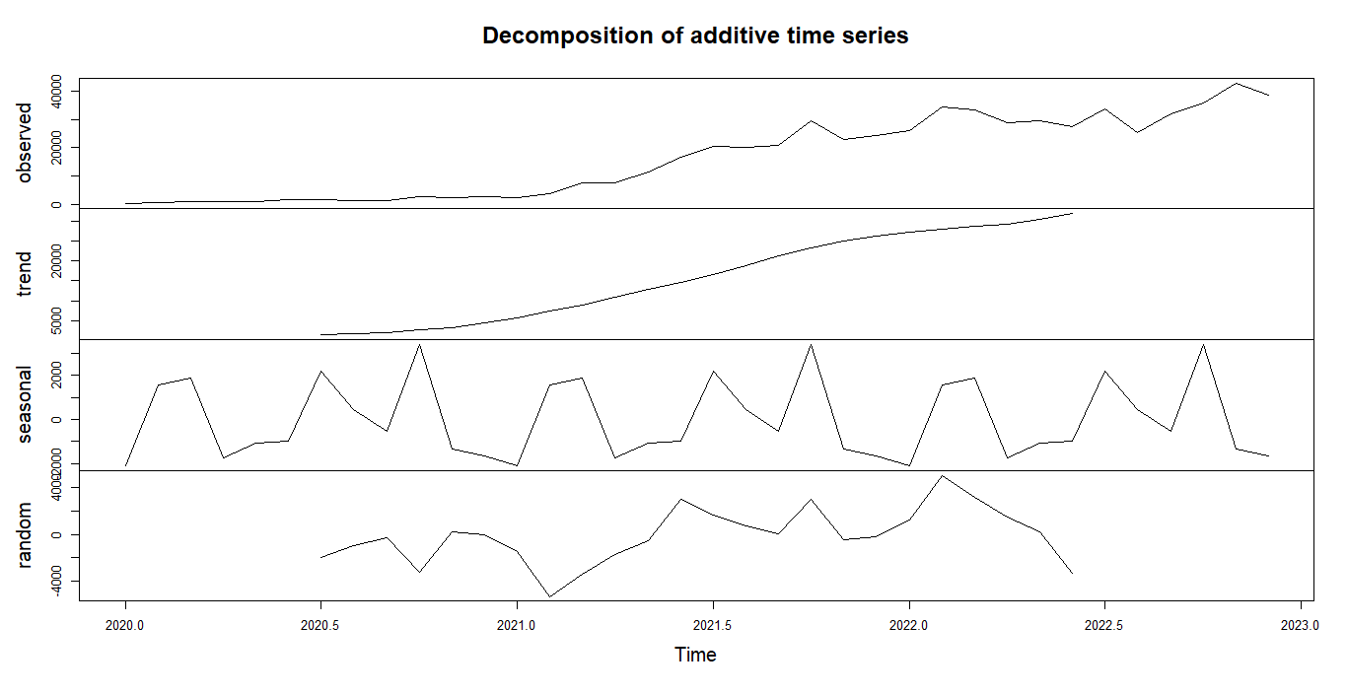
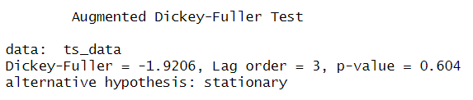
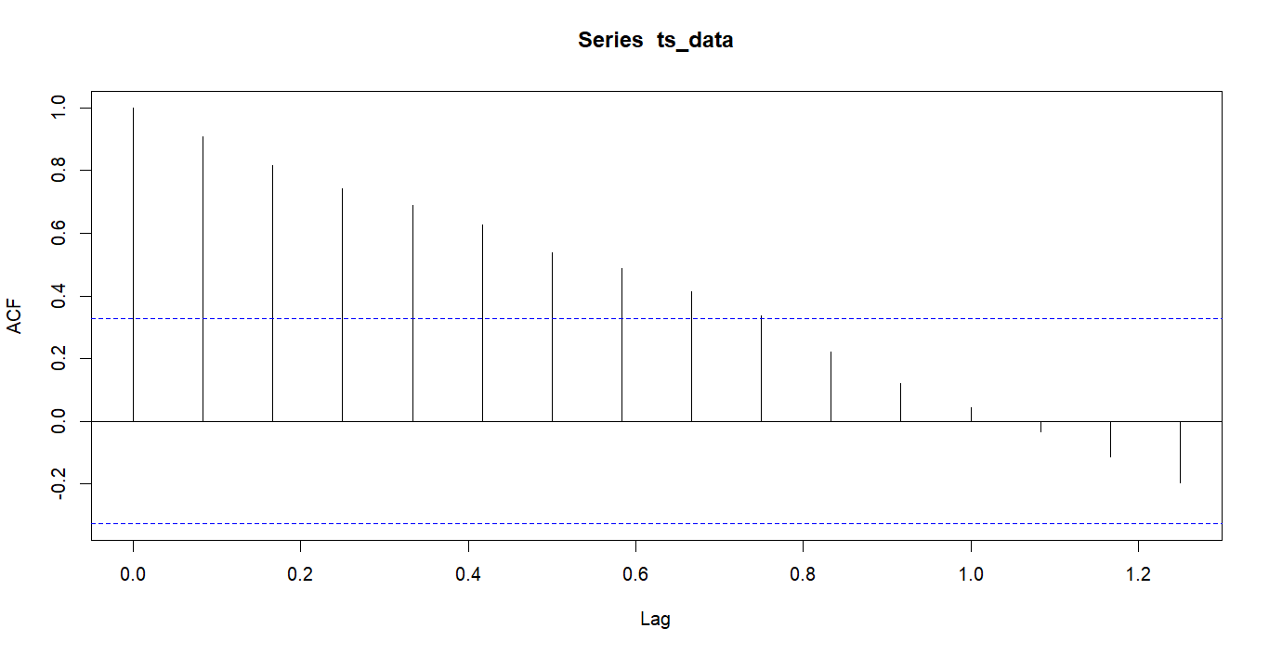
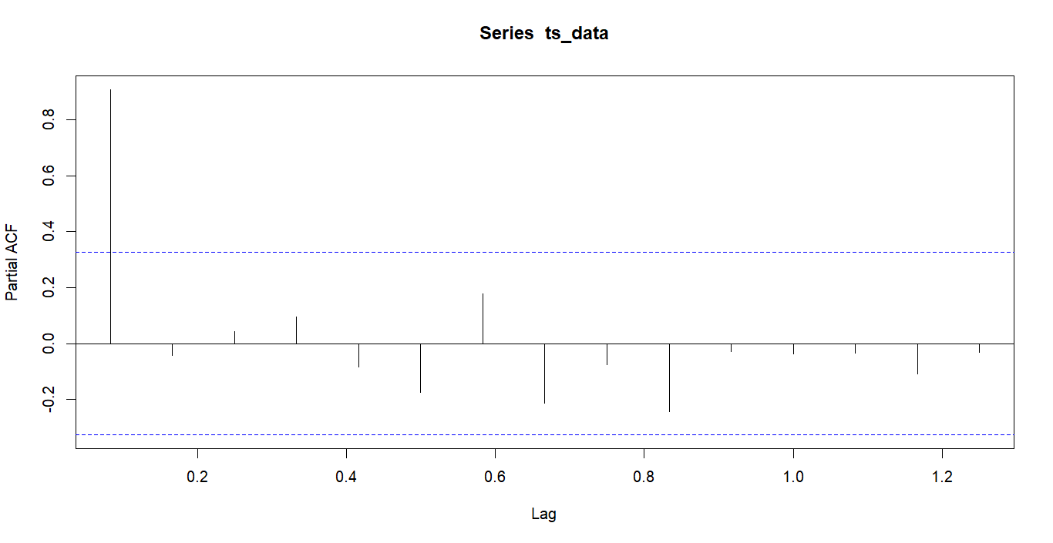

4.3. MODEL DESCRIPTION
We applied the Autoregressive Integrated Moving Average (ARIMA) model to the cabbage prices data. The ARIMA model is characterized by its non-seasonal and seasonal components, represented by the parameters (0,1,1) (0,1,0) [12]. The non-seasonal components capture the temporal dynamics within the data, while the seasonal components account for recurring patterns over a specific time interval.

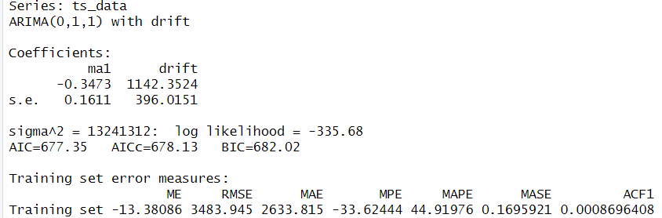

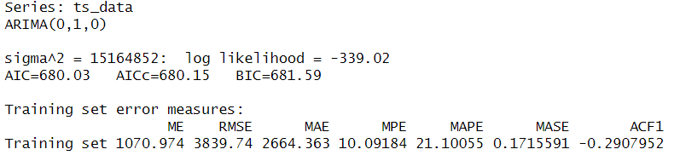

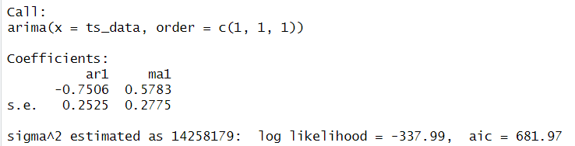

4.5. INTERPRETATION OF FINDINGS
The fitted ARIMA model was used to generate forecasts for future values of the time series. We forecasted the next 12 time points to provide a one-year outlook. The forecasted values were accompanied by prediction intervals to quantify the uncertainty associated with the forecasts.

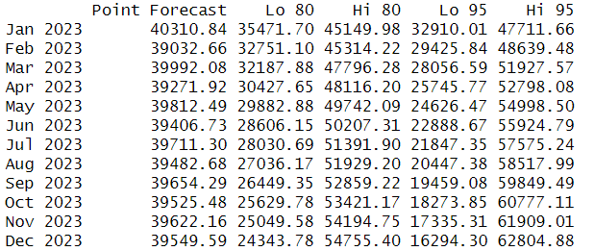
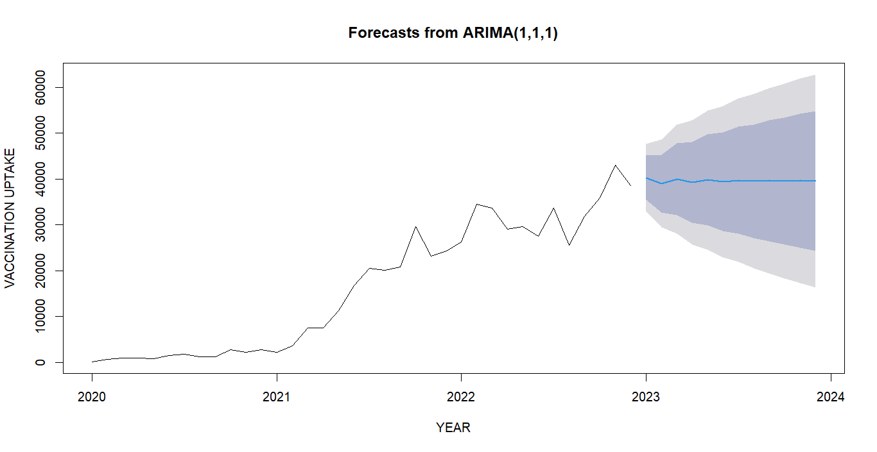

CONCLUSION
In conclusion, in the context of forecasting COVID-19 vaccine uptake, the ARIMA model offers several advantages. It can capture underlying trends, seasonal variations, and other temporal patterns in vaccine uptake data, providing valuable insights for decision-making and resource allocation. By using historical vaccination data and relevant predictors, the ARIMA model enables accurate predictions of future vaccine uptake trends. Despite limitations, the forecast offers useful information for decision-making or planning.

REFERENCES
- Smith, P.J., et al. (2019). Predictors of U.S. influenza vaccination among adults. Vaccine, 37(37), 5168-5174.
- Brown, A., et al. (2020). A COVID-19 vaccine education campaign: Relationships between vaccine knowledge, vaccine attitudes, and vaccine acceptance. Human Vaccines & Immunotherapeutic, 16(10), 2219-2222.
- Larson, H. J., Clarke, R.M., Jarret, C., Eckersberger, E., Levin, Z., Schulz, W. S., …& Paterson, P. (2021). Measuring trust in COVID-19 vaccines: a multinational study. Vaccines, 9(8), 1-17.
- MacDonald, N. E. (2015). Vaccine hesitancy: Definition, scope and determinants. Vaccine, 33(34), 4161-4164.
- Correa, A., Hoberg, E., & Marcellin, R. (2020). Influenza vaccination rate prediction using time series and machine learning models. International Journal of Environmental Research and Public Health, 17(5), 1-13.
- Li, H., Chen, X., Huang, H., Yang, T., Qiu, Q., Jia, Y., ... & Wang, Y. (2021). Prediction of COVID-19 vaccine demand in China based on machine learning and internet search index: An observational study. JMIR public health and surveillance, 7(3), e28319.
- Wang, K., et al. (2021). COVID-19 vaccine acceptance among the general population: A meta-analysis of cross-sectional studies. Vaccine, 39(42), 6537-6542.
- Hohl, A., et al. (2019). Forecasting influenza vaccine uptake using data from publicly available online search queries. Vaccine, 37(5), 743-748.
- Kossyvakis, A., et al. (2020). Machine learning in forecasting COVID-19 vaccine uptake. International Journal of Environmental Research and Public Health, 17(23), 8973.
- Baidu, L., et al. (2021). Predicting COVID-19 vaccine uptake using machine learning in the United States: A cross-sectional study. Vaccines, 9(5), 438.
- Matrajt, L., et al. (2020). Vaccine optimization for COVID-19: Who to vaccinate first? Science Advances, 7(6), eabf1374.
- Yamin, D., et al. (2021). A model to predict SARS-CoV-2 vaccine uptake in the United States. Proceedings of the National Academy of Sciences, 118(25), e2026583118.
- Ruiz, J. B., Bell, R. A., & Scherer, A. M. (2021). The impact of communication on COVID-19 vaccine acceptance: Using vaccine administration and attitudes tracking survey (VAATS) data. Vaccine, 39(14), 1-8.
- Smith, L. E., Amlôt, R., Weinman, J., Yiend, J., Rubin, G. J., & Fear, N. T. (2021). A systematic review of factors affecting vaccine uptake in young children. Vaccine, 39(33), 1-15.

